**Descripciones**

**Adjetivos**

An adjective is a word that describes a noun. Adjectives can describe shape, color, size, and many other things about a noun.

Spanish adjectives are very different from English adjectives, for two reasons:

1. In English, adjectives are always found in front of the noun, but Spanish adjectives usually follow the noun that they modify.

2. Spanish adjectives change to agree in gender and number with the nouns that they modify. This means that there can be up to four forms of each adjective:

Masculine singular – el libro blanco

Feminine singular – la mesa roja

Masculine plural – los libros blancos

Feminine plural – las mesas rojas

I. Most Spanish adjectives end in o. To make them feminine, change the ‘o’ to an ‘a’. To make them plural, add –s.

Singular plural singular plural

masc rojo rojos malo malos

fem roja rojas mala malas

II. When the adjective ends in a or e, there is no difference between the masculine and feminine forms, and the plural is created by adding -s.

singular plural singular plural

masc triste tristes realista realistas

fem triste tristes realista realistas

III. When the adjective ends in any consonant except n, r, or z, there is no difference between the masculine and feminine forms, and the plural is created by adding -es.

singular plural

masc fácil fáciles

fem fácil fáciles

IV. When the adjective ends in z, there is no difference between the masculine and feminine forms, and the plural is created by changing the z to a c and adding -es. (Why is this?)

singular plural

masc feliz felices

fem feliz felices

**Posición del adjetivo -**

Spanish adjectives may be found before or after the nouns they modify, depending on various factors: Descriptive adjectives follow nouns, while limiting adjectives precede nouns.

You write the adjective after the noun with

1. ***Descriptive adjectives*** distinguish between different nouns of the same type and usually* follow the nouns they modify. Por ejemplo…

el pájaro verde the green bird

el vestido rojo the red dress

Notes

A. Two descriptive adjectives modifying the same noun may use the conjunction ‘y’ – which means ‘and’

la camisa roja y bonita the beautiful red shirt

el libro emocionante e interesante the thrilling and interesting book

B. To use a descriptive adjective indicating an inherent quality of a noun; you may use the adjective prior the noun.

la blanca nieve the white snow

los altos árboles the tall trees

C. to express a subjective opinion the descriptive adjective must precede the noun.

el mejor cantante the best singer

Es una buena idea. It’s a buena idea.

**Spanish noun-adjective agreement. “concordancia del adjetivo y el sustantivo”,**

**Spanish masculine adjectives**

Most adjectives must agree in gender with the noun they modify. When describing a masculine noun like “hermano”, we must use a masculine adjective as well such as such as “activo”. Just like with nouns, Spanish masculine adjectives usually end in the vowel -O like “honesto” and “Creativo”.

e.g. “El perro es bonito y gordo.

Some examples of common Spanish masculine adjectives are:

Alto (tall), Bajo (short), Bueno (Good), Afortunado (lucky), Famoso (famous), Malo (bad) and Pequeño (small)

**Spanish Feminine Adjectives**

When describing feminine nouns like hermana (sister), we have to use a feminine adjective like bonita (pretty) or Graciosa (fun), and try not to use the masculine form.

Spanish feminine adjectives are the same words with a small change at the end from -O to -A, e.g. “Bueno” to ‘Buena’. Make sure you have used the correct form.

**Making Spanish adjectives agree with plural nouns.**

As we mentioned above, Spanish adjectives normally have a singular and a plural form. The rules are the same used to form the plural of nouns. Examples:

La casa bonita (the pretty house) – la casa es bonita (the house is pretty)

Las casas bonitas – (the pretty houses) - las casas son bonitas (the houses are pretty)

El perro gordo (the fat dog) – el perro es gordo (the dog is fat)

Los perros gordos (the fat dogs) – los perros son gordos (the dogs are fat)

Notice that all the words, including the subject pronoun and the verb SER as well, will change so that there is actual Spanish noun-adjective agreement, and the sentence makes sense.

**Activity – DRAG and Drop-** Put in order these words and construct the following sentences. **To present this activity all this words must be scrambled**

1. Niños – ellos – inteligentes – unos – muy – son Ellos son unos niños muy inteligentes.
2. Es- arquitecto – José – un – exitoso. José es un arquitecto exitoso.
3. Amigos – somos – nosotros – buenos . Nosotros somos buenos amigos.
4. Es- ella – señora – amable -una. Ella es una señora amable.
5. Mujeres – ellas – trabajadoras – son – unas. Ellas son unas mujeres trabajadoras.

**Las descripciones personales y físicas en español (we could add some graphics if we have on hair/eyes/)EXAMPLE ONLY**

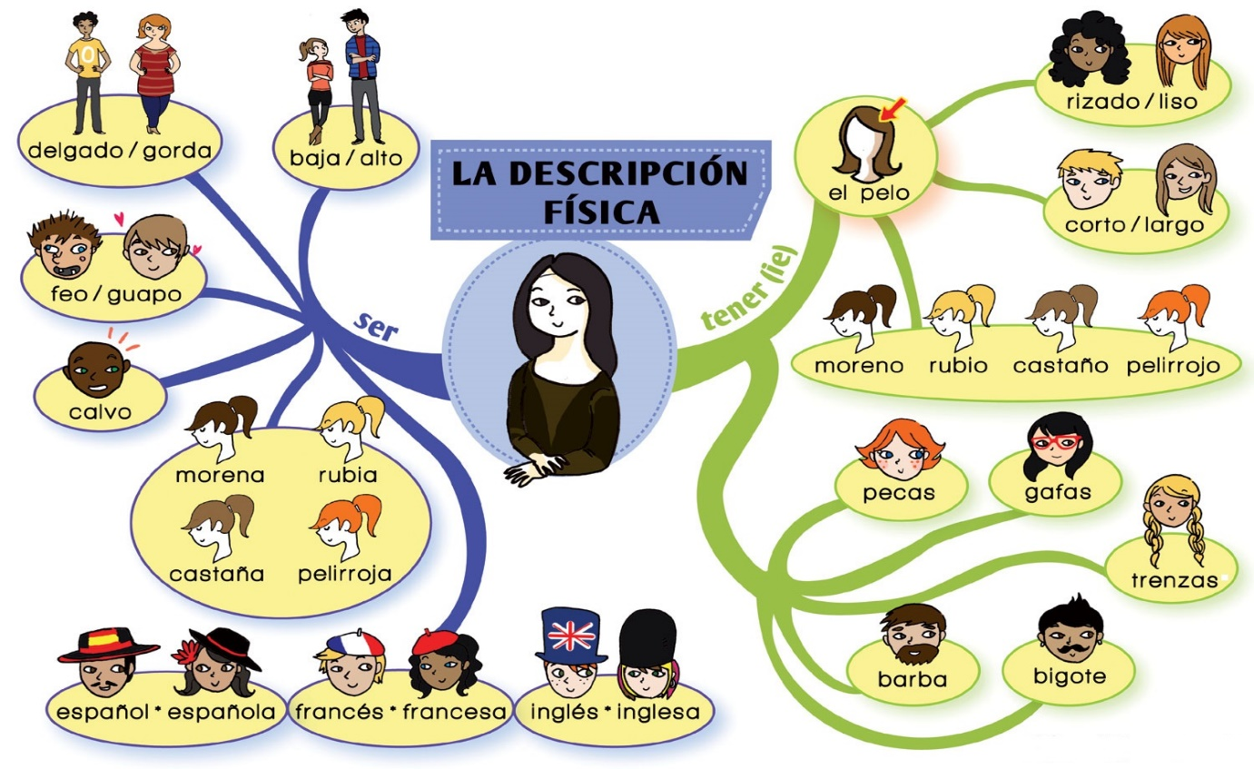

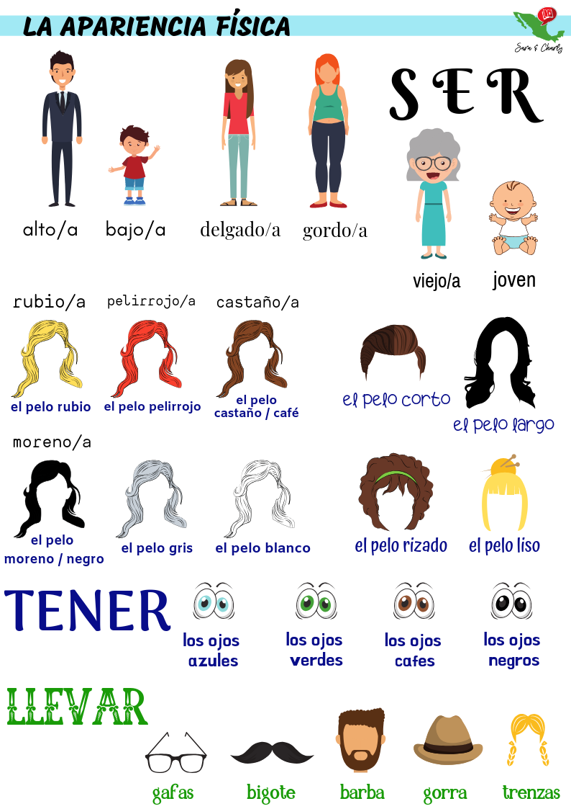

¿Como eres? (what do you look like)

¿Como es? (what does he/she/it/look like?)

Soy… Alto/alta

Bajo/baja

Delgado/delgada

Gordo/gorda

Es Alto/alta

Bajo/baja

Delgado/delgada

Gordo/gorda

Tengo el pelo negro

el pelo castaño

el pelo rojo

el pelo rubio

Tiene el pelo negro

el pelo castaño

el pelo rojo

el pelo rubio

Tengo (I have)

los ojos azules

los ojos verdes

los ojos marrones

los ojos negros

Tiene los ojos azules

los ojos verdes

los ojos marrones

los ojos negros

Tengo pecas Tiene pecas

Llevo gafas

barba

bigote Lleva gafas

barba

bigote

**ACTIVIDADES PRACTICAS**

**Complete the sentences using the correct form of the verb and the correct ending of the adjective**

1) Me llamo María, __________ alt____ y delgad _____

2) Mi padre _________ alt____ y tiene los ojos gris__

3) Mi madre _______ baj ____ y gordit ____

4) Mi hermanos __________ travies______ y y antipátic _______

5) ¿Y vosotros? ¿ _________ trabajador______?

6) Sí, nosotros no --- perezos

7) Mario, tú _______ muy guap_____

8) Mi hermano y yo __________ simpátic______

9) Mi perro se llama Chato, ____ Lent_____ y gord____

KNOW HOW

The verbs SER and TENER for physical descriptions

We often use the verb SER plus a few common adjectives to describe people in Spanish. SER will be used in two forms: ES for a single object and SON for many. In order to describe people’s eyes, nose and other parts of the body in Spanish, we will use the irregular verb TENER, like in the sentence “Tengo pelo largo” which describes hair in Spanish. Remember that adjective placement and their agreement with nouns are very important to make accurate descriptions of people in Spanish. In the first example, we will see the verbs SER and TENER in use with some common adjectives for physical descriptions.

ACTIVITY

MATCH (drag and drop the correct translation to these descriptions in Spanish)

1. Tengo los ojos marrones. (correct answer: I have brown eyes)

2. Tengo el pelo rubio y liso. (correct answer: I have blonde, straight hair)

3. Tiene los ojos azules. (correct answer: He/She has blue eyes)

4. Llevo barba. (correct answer: I have a beard)

5. Lleva bigote. (correct answer: He has a moustache)

6. Llevo gafas. (correct answer: I wear glasses)

7. Tiene el pelo rojo y lleva gafas. (correct answer: He/she has red hair and wears glasses)

8. Tiene los ojos verdes y lleva barba (correct answer: He/she has green eyes and a beard)

9. Tengo el pelo rizado y corto. (Correct answer: I have short, curly hair)

10. Tiene el pelo castaño y ondulado, lleva gafas y bigote (correct answer: He has brown, wavy hair, he wears glasses and has a moustache)

**DESCRIPCION PERSONALIDAD**

¿Cómo eres?

Soy…

Extrovertido/a Extroverted

Hablador(a) Talkative

Simpático/a Kind

Sociable Sociable

Formal Formal

Trabajador(a) Hard-working

Paciente Patient

Travieso/a Naughty

Impaciente Impatient

Antipático/a Unkind

Tímido/a Shy

Reservado/a Reserved

Perezoso/a Lazy

DESCRIPCIONES GENERALES (físico y personalidad)

CONNECT these words with the correct translation in English (second column must go scrambled)

Soy… I am

Alto tall

Bajo Short

Feo ugly

Intelectual intellectual, intelligent

Cómico funny

Serio serious

Fenomenal great

Simpático nice, amicable

Delgado slim

Gordo chubby

Guapo Good looking

Inteligente intelligent

Antipático not nice

Divertido fun

Activo active

Perezoso lazy

Trabajador had working

Atlético sporty/ atlhletic

Tímido shy, timid

EJERCICiO CON AUDIO

¿Cómo eres tú?

Yo me llamo Pedro. Tengo 25 años. Soy alto y delgado. Creo que soy guapo. Tengo pelo corto, negro y rizado y ojos azules. Soy moreno. Peso unos 70 kilogramos. No soy gordo. Me gusta hacer ejercicio.

Translation:

My name is Pedro. I’m 25 years old. I am tall and slim. I believe I am good looking. I have short, black and curly hair and blue eyes. I am brunnet. My weight is 70 kg. I’m not fat. I like to exercise.

**ACTIVITY 1 WITH ADJETIVES** (personality descriptors) –

Lista de adjetivos para describir personalidad

Read the following list of adjectives to describe personality and sellect its Opposite (antonimo) from the list

Generoso/a

Gracioso/a

Hablador/a

Honesto/a

Listo/a

Simpatico/a

Sincero/a

Trabajador/a

Tranquilo/a

Valiente

Tonto/a

Aburrido/a

Antipático/a

Tacaño/a

Callado/a

Serio/a

Deshonesto/a

Cobarde

Triste

Vago/a - perezoso/a

Maleducado/a

Nervioso/a

Introvertido/a

Mentiroso/a

**ACTIVITY 2 - DRAG AND DROP**

**Read the following definitions and drag and drop the best adjective to its correspondant**

cariñoso/a – le gustan mucho los besos, los abrazos y las expresiones de amor

Estudioso/a – le gusta mucho estudiar

Presumido/a – le gusta hablar de si mismo/a y admirar constantemente sus cualidades

Solitario/a – no le gusta ni las reuniones, ni las fiestas y tampoco estar con gente

Prudente – no es impulsivo y le gusta pensar primero y actuar después

Tímido/a – no le gusta hablar en público

Aventurero/a – le gusta viajar a lugares exótico y tener muchas experiencias

Organizado/a – le gusta planificar y seguir un horario y una estructura

**THE ASWERS MUST BE ALL SCRAMBLED AT THE BOTTOM TO BE CHOSEN**

LOS COLORES **(please the images are here only as inspiration – Any image/illustration is acceptable)**

LOS COLORES 1.- Relaciona las imágenes con las palabras:

1  2  3  4 

5  6  7  8 

9  10 

A.- negro __ B.- amarillo __ C.- verde __ D.- rosa __ E.- naranja __ F.- blanco __ G.- marrón __ H.- azul __ I.- violeta __ J.- rojo _

**To hear the audio you must complete these sentences with the correct color expression.**

La leche es ______________________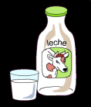 (blanca)

El petróleo es _____________________ negro

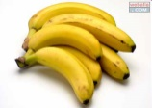

Los plátanos son __________________ amarillos

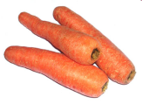Las zanahorias son ________________ naranja

El mar es _______________ azúl

La lechuga es ________________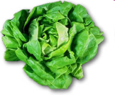verde

La sangre es _________________  roja

La camisa es __________________ 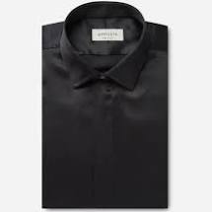negra

Los zapatos son _______________ 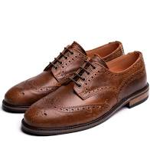marrones